**OPERATING SYSTEMS**

**Laboratory 3**

Name: Ujash

Surname:Patel

Index number: 36283

Date:11/5/2021

**Introduction**

* 10 points maximum.
* All commands must be executed in the Linux terminal. Don't use Linux GUI to solve the exercises.

**Exercise 1. (1 point)**

Check what access rights you have to the directory /home/*your_username*

Describe all directory rights.

*Paste the instructions:*

*I wrote ls - l*

*Paste the screenshots of the completed task:*

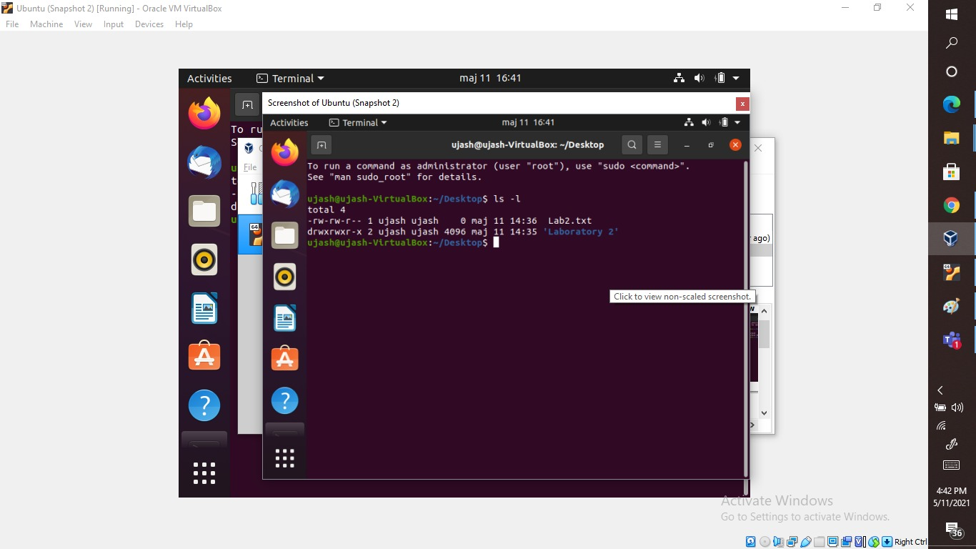

**Exercise 2. (1 point)**

Create an empty file named os.txt in your home directory

*Paste the instructions: touch os.txt*

*Paste the screenshots of the completed task*

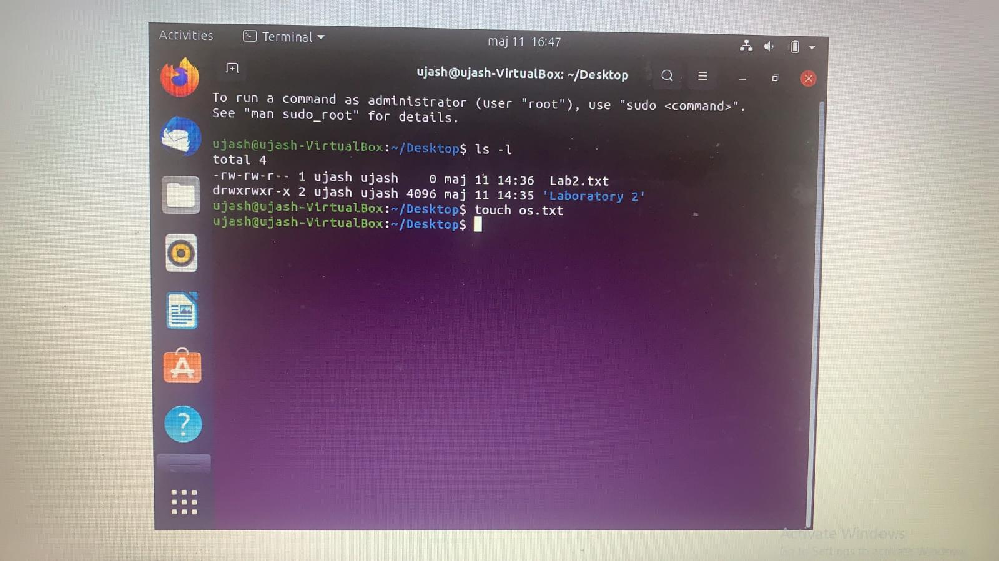

**Exercise 3. (2 point)**

Give yourself all rights to this file and remove all rights to this file from all other accounts

*Paste the instructions: chmod g – rwx os.txt*

*Chmod o- rwx os.txt*

*Paste the screenshots of the completed task*

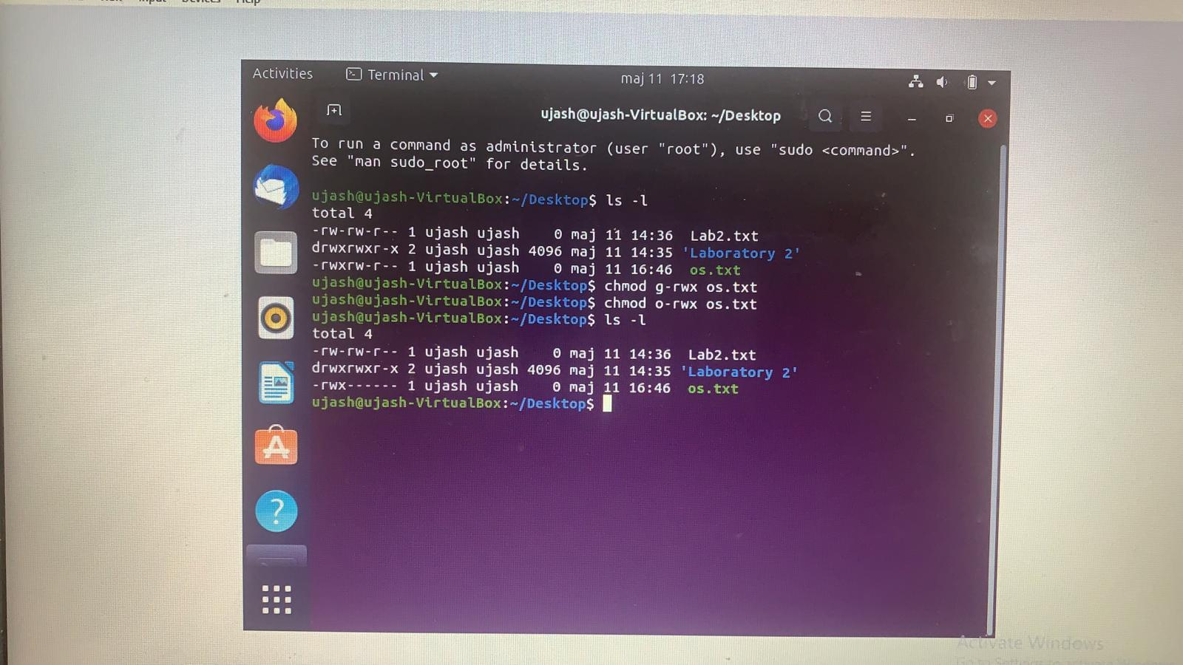

**Exercise 4. (1 point)**

Add a few lines of text to os.txt file

*Paste the instructions: echo “ This is what I added” > os.txt*

*Paste the screenshots of the completed task*

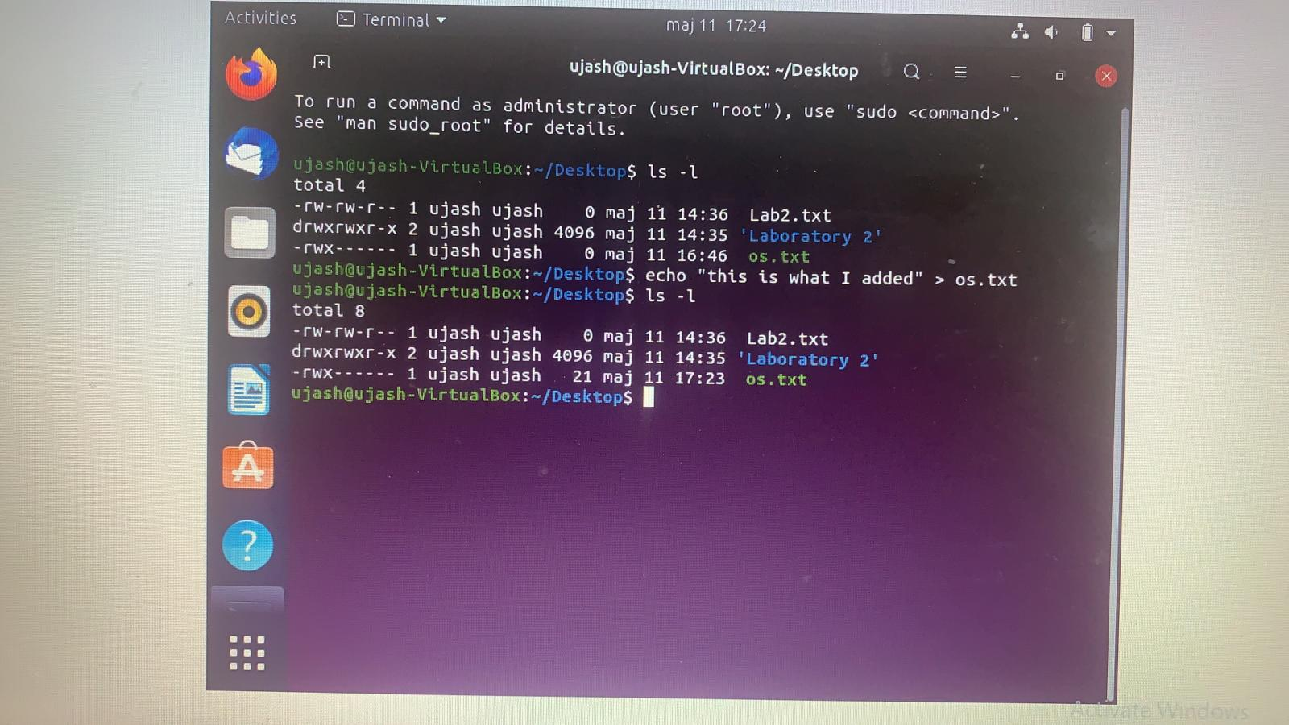

**Exercise 5. (2 points)**

Count how many characters, words and lines of text are in the os.txt file

*Paste the instructions: cat os.txt*

*Paste the screenshots of the completed task*

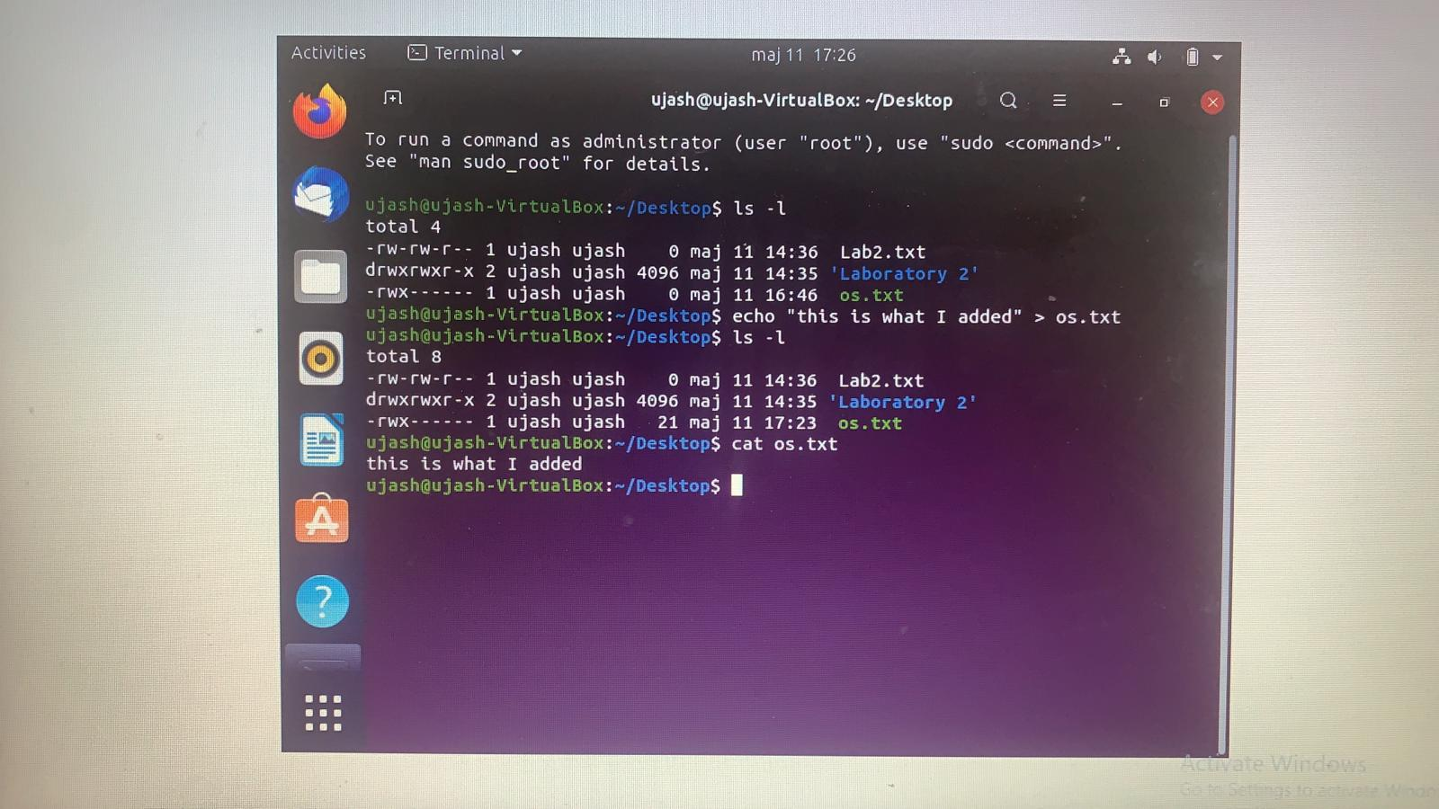

**Exercise 6. (1 point)**

While in your home directory, make a hard link to the file /etc/passwd

Check the operation of the hard link.

*Paste the instructions:* Ln os.txt h1.txt

*Paste the screenshots of the completed task*

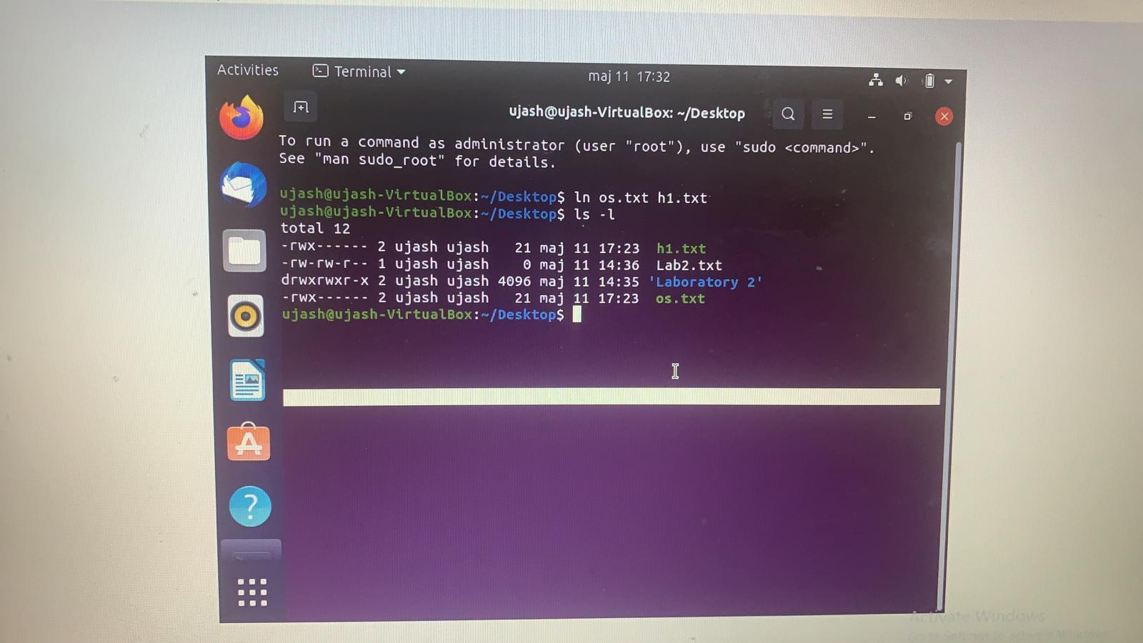

**Exercise 7. (2 points)**

Create a user named **student1**. Set the password "**123**" for the new account.

*Paste the instructions: sudo -s*

*Adduser user*

*(after that I added password and details about it)*

*Paste the screenshots of the completed task*

